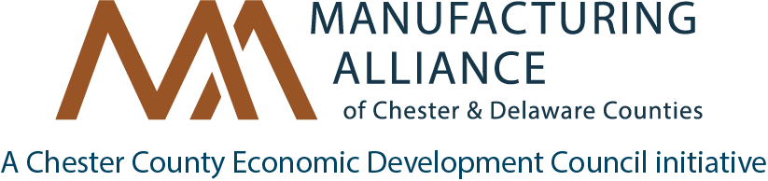

Grant Money Available to Reimburse up to 50% for these approved Live Trainings!
Manufacturing Training Funds for 2019-2020

The Manufacturing Alliance of Chester & Delaware Counties can help your organization maintain a competitive workforce with a Grant to offset partial costs of training (eligible employers/trainees can receive a reimbursement of up to 50% of course costs for each trainee). Funding is provided by the Pennsylvania Department of Labor and Industry and the Chester County Workforce Development Board.

Eligibility & Conditions
- Trainees must be employed residents of Pennsylvania.
- Training must be Live with tuition cost of at least $500.00, taking place between 01/01/2019 and 06/30/2020.
- This Grant ends June 30, 2020, or when Grant money is spent.
- The following Training topics are currently eligible for partial reimbursement for the 2019-2020 program year.
- All applications will be reviewed by the Grant Committee for approval.

Below are the names of some of the Trainings we can subsidize. Is the course you want to take not listed? We may be able to get it approved – contact us!

- Reading and Interpreting Blueprints and Technical Documents
- Industrial Drive Systems
- Mechanical Systems: Troubleshooting and Repair
- CNC Programming
- CNC Operations
- Programmable Logic Controls
- Microsoft Project Management
- Industrial Automation and Control
- Manufacturing Processes

If you or your employees have taken any of the classes listed above and you have not yet applied for grant funds, please contact us to discuss.

As a condition of the funding grant, recipients are asked to report a training outcome for each employee, such as a certification, a wage increase, new job title, or promotion. As required by the Department of Labor and Industry, trainees must provide their social security number (SSN) and complete a brief training evaluation following completion of the training. SSNs are used for state reporting only and not retained.

Disallowable costs include: conferences; non-certification or credential seminars, travel or other expenses; and lost wages or salary reimbursement.
Contact Jim Lauckner or Sherry Cockerham with questions, request for more information, or to receive timely notifications of SEI-approved training in the region.
Jim Lauckner, Sr. Project Consultant Sherry Cockerham, Project Coordinator
jlauckner@ccedcpa.com | (610) 321-8231 scockerham@ccedcpa.com | (610) 321-8213

